Exploratory Data Analysis on the Automobiles Dataset
Report

Introduction
This report summarizes the exploratory data analysis performed on the Automobile Dataset.
Data cleaning
The dataset contains 24 variables of automobiles manufacturers. The first task is removing redundant data, which cannot be converted into an integer value for analysis. The two variables normalized losses and symbolling are dropped from the dataset and the dataset is verified again to ensure that indeed the unused variables in analysis are removed. The analysis further removes any duplicate rows and returns the number of rows and columns using the shape() function. The total number of rows and columns returned after removing duplicates is (205, 24).
Missing Data
Any missing values in the dataset were replaced by NaN. Any extra white spaces in the column names were removed. The following columns were converted to numeric format, price, city-mpg, highway-mpg, engine-size, horsepower, peak-rpm, bore and stroke.

Data stories and visualizations
The dataset further classifies certain vehicles as hatchbacks. It further lists the price and make of the 5 most expensive cars, which are Mercedes-Benzes, BMW, and Porshe. The analysis compares manufacturers that build the most fuel-efficient vehicles and compares their average mpg for each vehicle and displays results in a bar chart. The following chart displays the average MPG of a car traveling in the city developed by manufacturers.
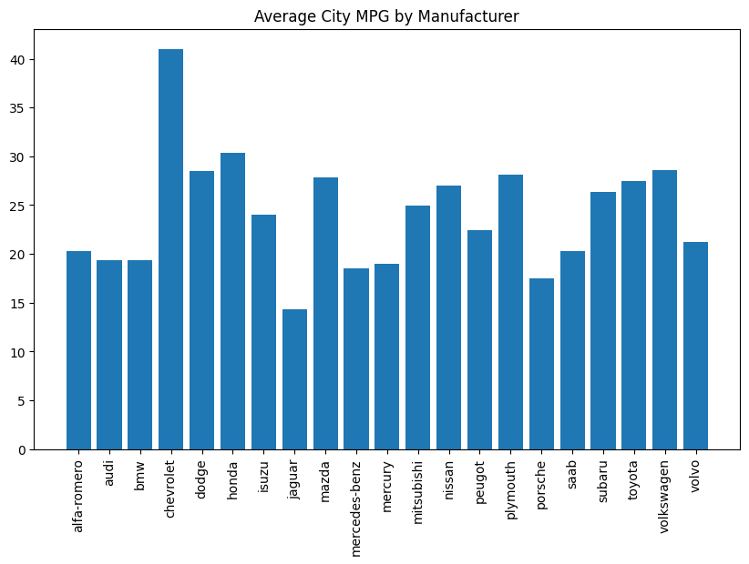
In the graph we can see that Chevrolet has the highest average of 40 MPG travelling in the city and Jaguar has the lowest average of 15 MPG travelling in the city.
The graph below shows which vehicle has the highest average fuel efficiency travelling on the highway. The graph shows that Chevrolet has the highest MPG of over 40 traveling on the highway and Jaguar has the lowest MPG of below 20 traveling on the highway.
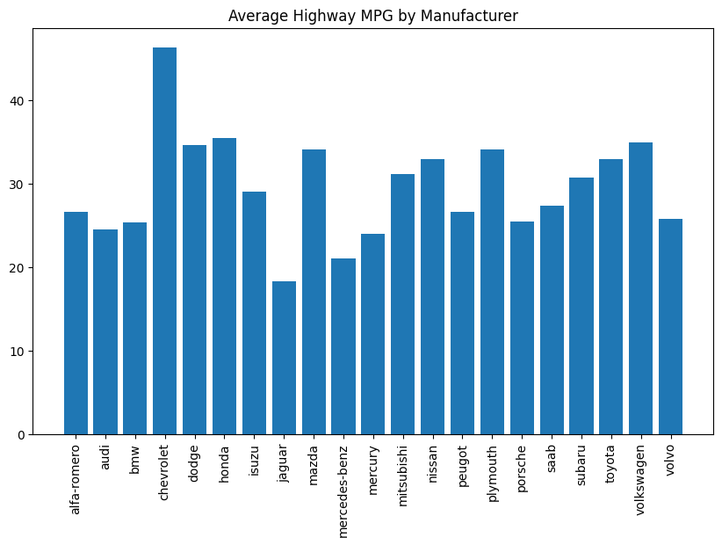

The dataset sorts out the list of vehicles according to engine size.

The report was written by Lungelo Ndabambi

